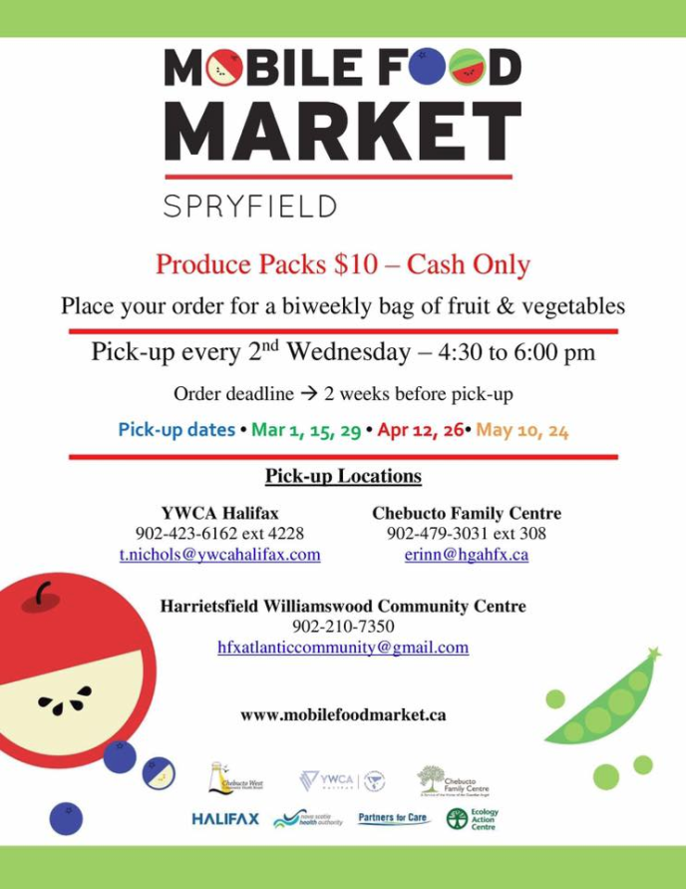
Produce Packs
Staff Contacts
Tammy Turple
Executive Director
Ext 309

Deborah Hutchinson
Office Administrator
Ext 301

Andrea Townsend
Centre Coordinator
Ext 302

Taylor Gear
Program Support
Ext 314

Nicole Clarke
Family Wellness
Ext 313

Sarah Hicks
Home Visitor/Fund Development
Ext 303

Krista Greencorn
Home Visitor
Ext 304

Ginny Hennigar
Playroom Facilitator
Ext 306

Erin Fair
Volunteer Doula Program
Ext 305

Whitney Cruikshank
Volunteer Doula Program
Ext 307

Erinn Bailie
Youth & Community Outreach
Ext 307

Jane Hall
Family Home Daycare
Ext 310

Sabah Randell
Parenting Educator
Ext 311

Jessie Harrold
Prenatal/Postnatal
Ext 312

Andrea Townsend
Centre Coordinator
Ext 302

Following the success of the Spryfield mobile food market, the Food Action Network has begun a 16 week Produce Pack pilot project. On a bi-weekly basis community members are able to purchase a $10 produce pack with enough fruits and vegetables for a single person.
There are four locations in our area designated for ordering and pick up. They are Chebucto Family Centre, Family SOS Greystone, YWCA Spryfield and the Harrietsfield Community Centre.

Donations
We love receiving donations, however due to limited space we would like to remind people that there are certain things that we can and cannot accept
We can accept | We are unable to accept
Maternity Clothing | Toys/stuffed animals
Childrens clothing (up to size 2T) | Clothing for older children
Car seats (not expired) | Kitchen gadgets
Cribs | Adult clothing
Strollers
Gift cards

Income Tax Clinic
Each year Deb Mathers provides free, basic income tax returns for people in the area. Appointments are on Tuesday afternoons and must be booked with the front desk.
Even if you are not employed outside of the home, you should still file your taxes. This will ensure you continue (if eligible) to receive GST/HST credits, Canada Child benefits etc.
Other organizations offering Tax Clinics include MP Andy Filmore’s office, Captain William Spry Public Library and Saint Paul’s Family Resources Institute.

Spry Café
If you are a group of friends, family, workplace or organization looking for a way to give back Spry Café is the answer!
The happiness and ability to sit down to a home cooked meal is not something everyone is able to do. To foster community, healthier eating habits and a welcoming environment we offer a once a month meal, Spry Café.
Contact Andrea at 902-479-3031 ext 302 or Andrea@hgahfx.ca to get involved.
Women’s Wellness Within
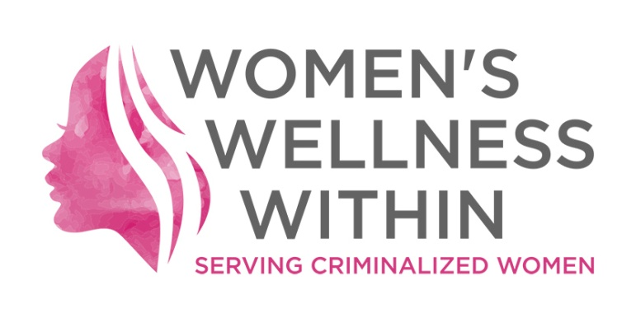
After 5 years of serving incarcerated women, Women’s Wellness Within (WWW) celebrated their incorporation with a launch party Friday March 10 at Art Bar +Projects.
The group offers workshops on everything from living and limiting stress to parenting and everything in between. Volunteer doulas provide doula services for those who are pregnant and interested, midwifery is also provided through the IWK.
For more details about Women’s Wellness Within, you can find on Facebook www.facebook.com/womenswellnesswithin
and onTwitter @WithinWomens
Stay Connected!
Chebucto Family Centre
ChebuctoFamilyCentre
@CFC_hfx

